Programming using C++

STUDENT TRACKING INFORMATION SYSTEM FOR VOCATIONAL SCHOOLS IN TURKEY

# Abstract

Vocational and technical high schools provide training in more than 130 occupations. Students are tracked by technical teachers at work with the guidance of school management and reports are prepared by teachers at each visit. It is better to save data digitally than on paper and benefit from a database management system. This paper aims at tracking of practical training process in vocational and technical high schools in Turkey and propose a web-based solution in order to digitalize their current processes and overcome the issues. The application creates an online student tracking system where the manager manages the system by inserting teachers, students, classes, companies, controlling added feedback and the teachers view their students and add feedback to the system for each student. To implement this as a web application we used LARAVEL as the Technology. To build any web application using LARAVEL we need a programming language such as PHP. LARAVEL uses MySQL to interact with the database as it can easily deploy and maintain a LAR AVEL application. Student Tracking System has been evaluated in a school. The teachers and the manager expressed their experiences and feelings during the process by pointing out that the system simplifies the process by providing many features.

**Keywords:** Vocational school, High school, Education, Online education, Laravel

39

# INTRODUCTION

It can be said that the vocational and technical education system in Turkey is divided into two parts: Theoretical (school training) and practical (in-company training). Theoretical education is provided in schools and practical training is provided in various companies. Vocational education centers provide mainly informal education. There are more than 19 different school types for vocational and technical high schools. There are also vocational education centers, Open Education and special private schools. After 8th class, students are placed to various schools according to transition from primary to secondary education system in Turkey. In ninth class, all students in high schools get the same education. After ninth class, there are two kind of school types for students in technical and vocational high schools: Technical High school and industrial high school.

Branch courses in technical and vocational high schools offers courses towards various professions. In addition, each branch contains some sub-branches. Technical high schools are not included in this generalization. Curriculums of technical high schools are similar with the general high schools as of the general education courses and branch courses of natural sciences branch (Altın, R., Yalçın, O., & Kalkan, Ö). There are about 225 occupational branches in vocational and technical education institutions. Industrial and technical branches: Plastics technology, apparel machinery maintenance and repair, Apparel, olive technology, computer-aided industrial modeling, decorative arts, automotive technologies, furniture and decoration, metal technology, machine technology, information technologies, electric technologies, electronic technologies, industrial cast- ing, nourishment technology, construction technology, plastic arts and design, etc. Commerce and tour- ism branches: Radio, cinema and television, public relations and promotion, accounting and finance, insurance trade and risk management, computers, marketing, catering services, accommodation services, travel agency, travel, recreational services, tourism, journalism, office management and secretary, etc. Social ser- vices branches: Child development and education, Skin care and hairdressing, organization services, etc.

40

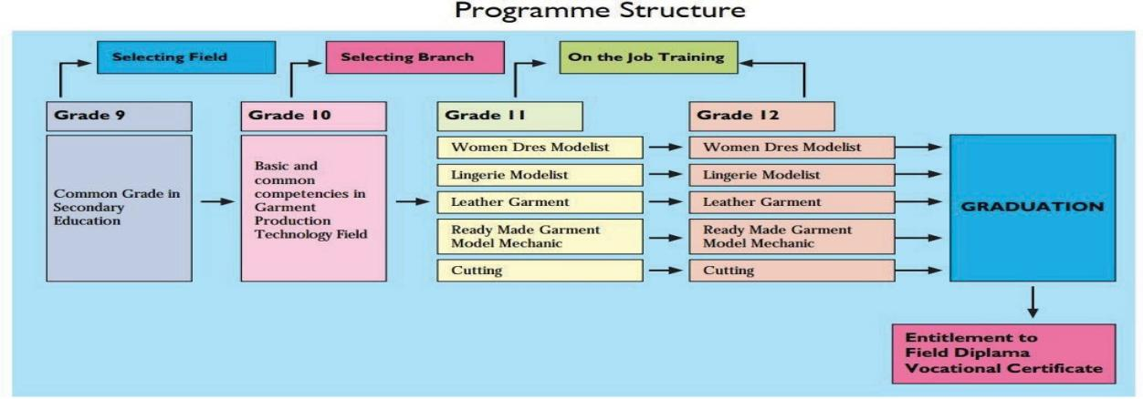

**Figure 1.** Program Structure

Practical training is 3 days a week during the 12th class for industrial vocational high schools and 5 days a week during the summer break between 11th and 12th class for technical vocational high schools (Figure 1).

The process starts with a meeting between technical manager and the technical teachers. Then, students assigned to teachers according to their distance to school and some other points like number of students to be tracked. If it is possible students assigned to teachers according to their branch to provide better student tracking process. For example, Students of information technologies assigned to teachers of information technologies or students of metal technologies to teachers of metal technologies. Some- times it is not possible to apply this kind of distribution because of overcrowded students. There should be a fair distribution to prevent any polemic. After getting information and feedback papers from man- ager; teachers visit assigned students at work according to the predetermined rules at the meeting. The intervals between the visits can be a week, a month, two weeks or even two months. At the visit, teach- ers ask questions to company manager, person in charge of the student, the student. Then, prepares a report for students and return them to manager to be stored.

# Motivation

Teachers visit assigned students at work after getting the list of the assigned students with some infor- mation on paper. These papers include the student’s name, class, phone number, company address etc. The intervals between the visits can be a week, a month, two weeks or even two months. At the visit, teachers ask questions to company manager, person in charge of the student and the student; prepares a signed report for each student and return them to manager to be stored.

41

An online student tracking system will be created to simplify the process and to provide a paper-free solution. The system will have all information about all the members of the system and will reduce pa- perwork and all the data gathered and stored on database might be used to create career opportunities for students in future. For example, the system will have many information about the students: their pic- tures, google map links of the companies they work for, their parents’ phone numbers, their phone num- bers and e-mails. Therefore, it will be easier for teachers to get information about the students during their visit at work. Teachers will be able to see the pictures of the students beforehand, be able to phone to them or their parents if an emergency emerges and all the information can be gathered from their mobile phones or tablets. Teachers will not need to carry around papers.

Teachers have to prepare reports about students at each visit. For instance, let us think that a teacher has five assigned students for a week that means at least five reports a week, twenty a month and two-hun- dred in a year. So, recording this reports in an online system will reduce the paperwork and creates various opportunities for students: Teachers can see development of students during practical training very easily by inspecting the reports saved online and all the reports gathered can be used for career opportunities.

Technology can play a crucial role in whole education system. Schools need to manage more informa- tion day by day. Student registration operations, student transfer operations, marks, document opera- tions, weekly lesson plans and some other operations all need DBMS because of the enormous data at hand. E-Okul is a web school management information system, which was opened for use in 2007 by MoNE of Turkey. All the info of students from entrance to graduation are recorded in the system. As we look deeply into the system, we can easily notice that there is not any record of practical training period, except year-end marks of students.

# Goal of this paper

The Student Tracking system will allow teachers the ability to view and complete the process and evaluation online. All that is needed is a computer or a mobile device and web browser. This system will enhance the quality of the teacher/student supervisory experience and facilitate better communication. In addition to these benefits, student-tracking system also offers the following benefits: Provides a paperless solution for tracking and recording students’ data, allows students to research potential field opportunities, information about companies can be accessed and updated very easily, allows technical instructor to follow students’ developments, provides teachers to easily access student information, allows teachers access to the feedback in a paperless system, increases communication between the School and companies.

42

The Student Tracking system aims to solve the problems encountered in the existing systems while becoming the first web-based student tracking system to be used in vocational high schools in Turkey. Most of the systems reviewed either lack feedback feature or the feature is not suitable enough for the Vocational High Schools. Some of them lack the feedback part. Although some systems have the feed-back feature, the feature is undetailed and not similar enough because of the differences in the educational systems. Vocational education in Turkey must have a unique student tracking software and our system is going to be designed to meet all the requirements needed. The second issue is the lack of information needed for all the users in the system. For example, parents’ phone numbers are not included in any of the system. However, it is very important for the teachers when they cannot reach the students on the field. Another important information deficit is google-map info of the company for teachers to find companies easily. There is also other important information needed because of the uniqueness of the vocational education in Turkey. The third issue is that most of the system out there are created with old technologies. That is why there is some performance, security and visual quality issues. Our system is going to be PHP, LARAVEL based, and LARAVEL’s own security precautions, visual standards and performance features are going to be implemented to the system. The system was scanned with a web vulnerability scanner and a web application scanner and no vulnerabilities encountered during the process.

# System functional requirements

* + - * 1. **Description of the System Users**

A system user is a person who interacts with a system using an interface to gain something.

# Technical Manager

Manager is also a teacher or a technical manager who is assigned by the school director to manage the student tracking process. She has the responsibility of adding, deleting and modifying the teachers, students or companies to the system. She has also the responsibility of viewing feedback and warning teachers if something missing. Manager should be able to add, modify and delete teachers, students and companies; can define username and password to the added teachers; can get the information of any member; can view all the feedback; can sign the feedback as controlled or not controlled.

# Teachers

Teacher is assigned by the technical manager to follow the students closely on the job training. She has the responsibility of adding, deleting and modifying the feedback to the system. She can also view the students related to her with their detailed information; can view the related students; can view details of a specific student; can fill up; delete/modify feedback (If it is not checked by the manager).

Write a simple program to help the teacher perform his functions

Hand in the work on 14th March 2024